Exercise 7: Data Manipulating Language
In this practice, you add rows to the MY_EMPLOYEE table, update and delete data from the table, and control your transactions. You run a script to create the MY_EMPLOYEE table.

Manipulating Data
The HR department wants you to create SQL statements to insert, update, and delete
employee data. As a prototype, you use the MY_EMPLOYEE table before giving the
statements to the HR department.

Note: For all the DML statements, use the Run Script icon (or press [F5]) to execute the
query. This way you get to see the feedback messages on the Script Output tabbed page.
For SELECT queries, continue to use the Execute Statement icon or press [F9] to get the
formatted output on the Results tabbed page.

Insert data into the MY_EMPLOYEE table.
1) Run the statement in the lab_09_01.sql script to build the MY_EMPLOYEE table
used in this practice.

create table MY_EMPLOYEE (
ID NUMBER(4) NOT NULL,
last_name VARCHAR(25),
first_name VARCHAR(25),
userid VARCHAR(8),
salary NUMBER(9,2));

2) Describe the structure of the MY_EMPLOYEE table to identify the column names.
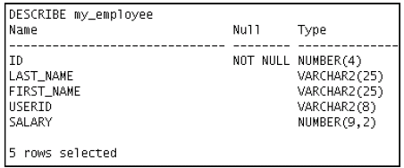
desc MY_EMPLOYEE;
3) Create an INSERT statement to add the first row of data to the MY_EMPLOYEE table
from the following sample data. Do not list the columns in the INSERT clause. Do not
enter all rows yet.
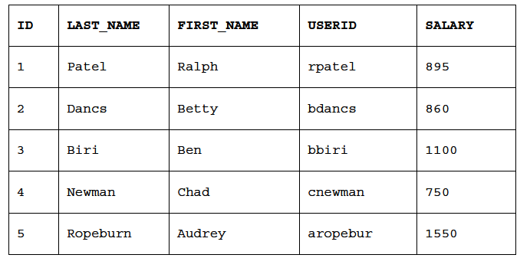
insert into my_employee
values (1, 'Patel', 'Ralph', 'rpatel' , 895);
4) Populate the MY_EMPLOYEE table with the second row of the sample data from the
preceding list. This time, list the columns explicitly in the INSERT clause.

insert into my_employee(id,first_name,last_name,user_id,salary)values(&id,'&first_name','&last_name','&user_id',&salary);

5) Confirm your addition to the table.
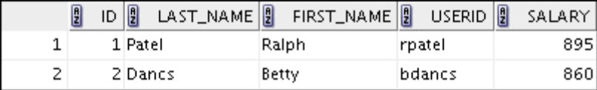
select * from my_employee;
6) Write an INSERT statement in a dynamic reusable script file to load the remaining
rows into the MY_EMPLOYEE table. The script should prompt for all the columns (ID,
LAST_NAME, FIRST_NAME, USERID, and SALARY). Save this script to a
lab_09_06.sql file.

7) Populate the table with the next two rows of the sample data listed in step 3 by
running the INSERT statement in the script that you created.

8) Confirm your additions to the table.
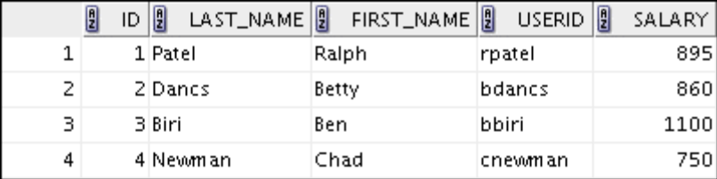
9) Make the data additions permanent.

Update and delete data in the MY_EMPLOYEE table.

10) Change the last name of employee 3 to Drexler.

update my_employee set last_name='drexler' where id=3;

11) Change the salary to $1,000 for all employees who have a salary less than $900.

update my_employee set salary=1000 where salary < 900;

12) Verify your changes to the table.
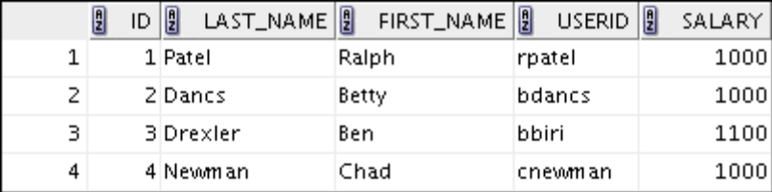
13) Delete Betty Dancs from the MY_EMPLOYEE table.

delete from my_employee where first_name= 'Betty' and last_name = 'Dancs';

14) Confirm your changes to the table.
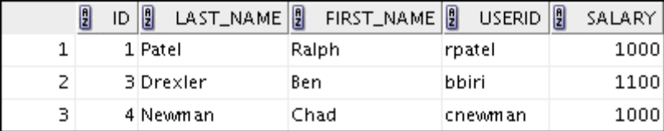

15) Commit all pending changes.

Commit;

Control data transaction to the MY_EMPLOYEE table.

16) Populate the table with the last row of the sample data listed in step 3 by using the
statements in the script that you created in step 6. Run the statements in the script.

17) Confirm your addition to the table.
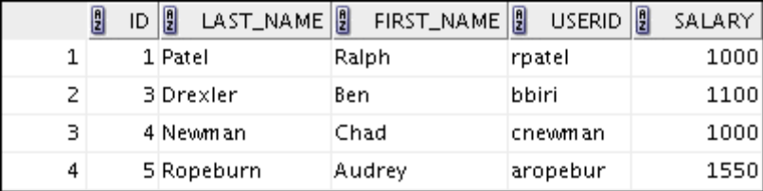

18) Mark an intermediate point in the processing of the transaction.

savepoint sv1;

19) Delete all the rows from the MY_EMPLOYEE table.

delete from my_employee ;

20) Confirm that the table is empty.
select * from my_employee;

21) Discard the most recent DELETE operation without discarding the earlier INSERT
operation.

rollback sv1;

22) Confirm that the new row is still intact.

23) Make the data addition permanent.

If you have the time, complete the following exercise:

24) Modify the lab_09_06.sql script such that the USERID is generated automatically
by concatenating the first letter of the first name and the first seven characters of the
last name. The generated USERID must be in lowercase. Therefore, the script should
not prompt for the USERID. Save this script to a file named lab_09_24.sql.
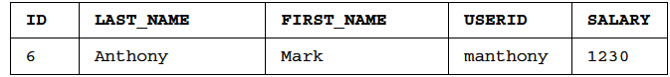
insert into my_employee (id,first_name,last_name,userid,salary) values
(&id,'&&first_name', '&&last_name',concat(substr('&first_name',1,1), substr('&last_name',1,7)), &salary );
25) Run the lab_09_24.sql script to insert the following record:

26) Confirm that the new row was added with correct USERID.
